SQL FILE

TABLE 1 – IMDB NAME BASICS

1. Nconst – The allotted code given to each person in the dataset – unique to every person

Min – 9

Max – 10

No null values

Data type - String

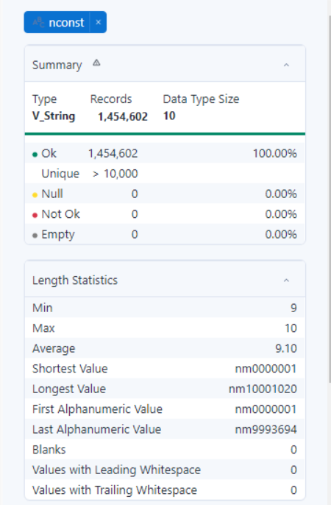

1. primaryName – The name of a person consisting first and last name that is uniquely identified with nconst

Min – 1

Max – 95

No null values

Data type - String

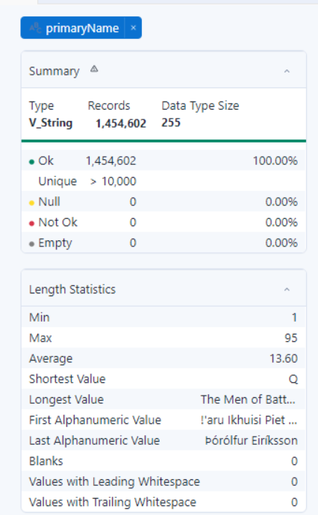

1. birthyear – The year the person was born.

Min – 2

Max – 4

No null values

Data Type - String

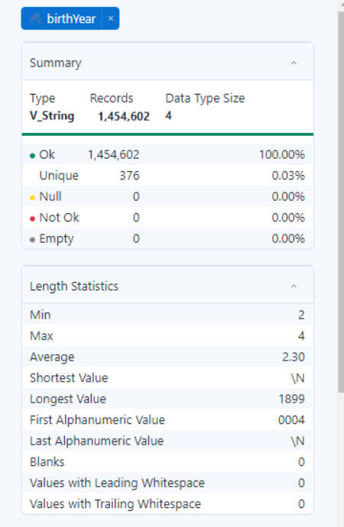

1. deathyear -The person identified to die in that year.

Min – 2

Max – 4

No null values

Data type - String

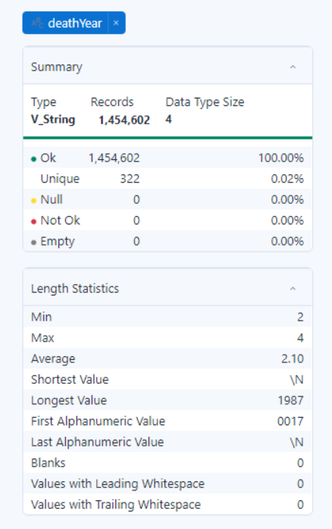

1. primaryProfession – Professions of a person include – actors, directors, producers, music dept. etc

Min – 5

Max – 65

No null values

Data type - String

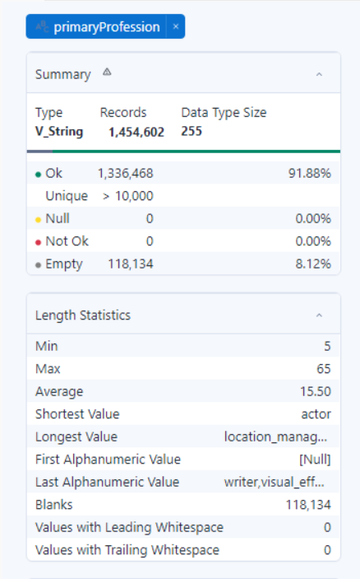

1. knownfortitles – The code that is allotted to Titles.

Min – 2

Max – 59

No null values

Data type - String

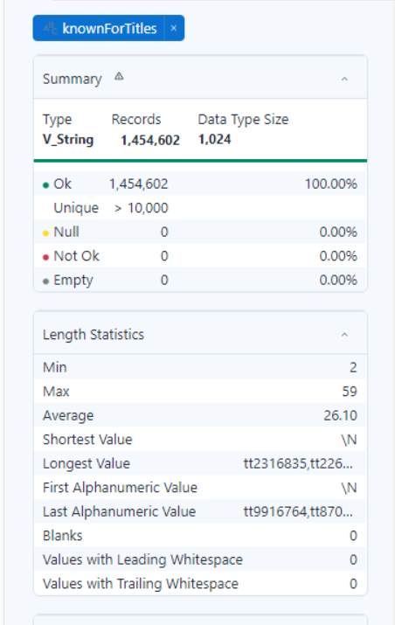

1. DI_create_DT - Created date in the system

No null values

Data type - Datetime

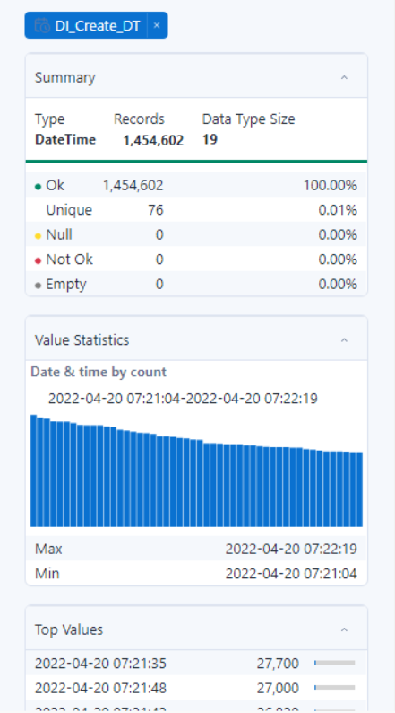

TABLE 2 – IMDB TITLE AKAS

1. titleId – Id given to the title of the movie

Min – 9

Max – 10

No null values

Data type - String

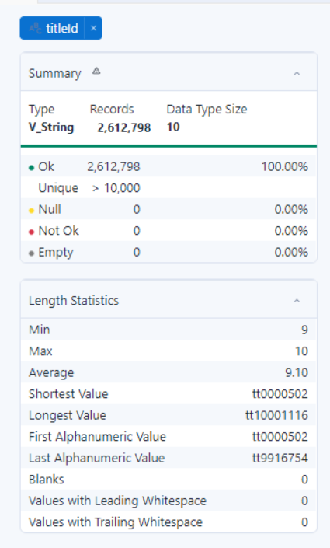

1. ordering – The movies was published in different languages in different regions

Min – 1

Max – 149

No null values

Data type - Int

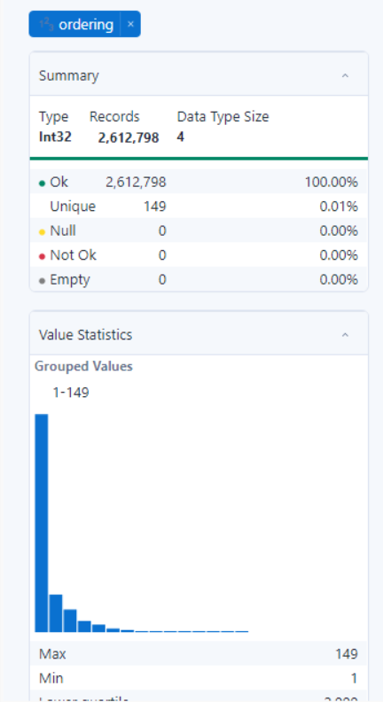

1. title – The name given to the movie that was released

Min – 1

Max – 273

Data type - String

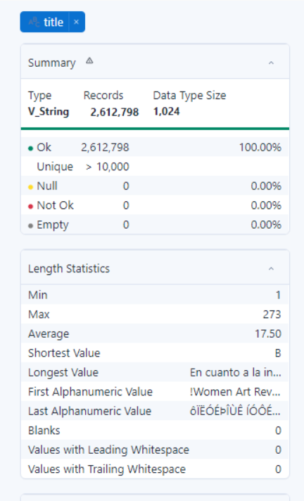

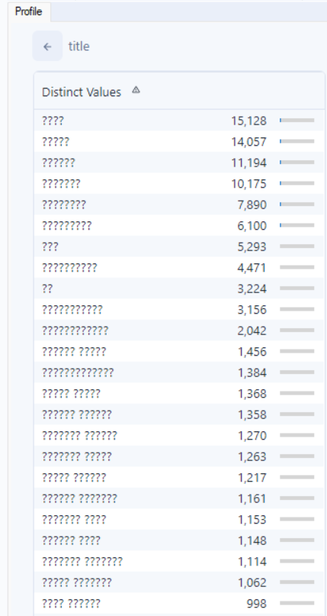

1. region – The place the movie was released in

Min – 2

Max – 4

No null values

Data type - string

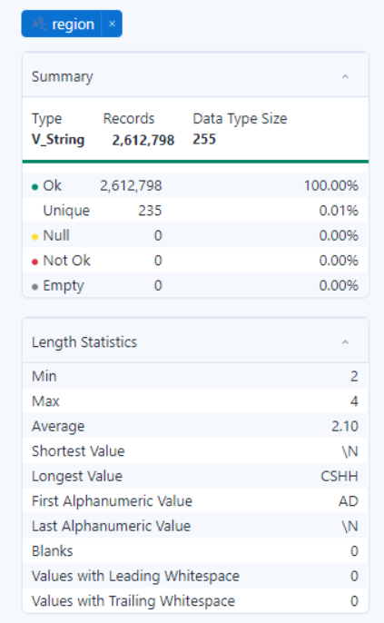

1. language- The language the movie was released in

Min – 2

Max – 3

No null

Data type - string

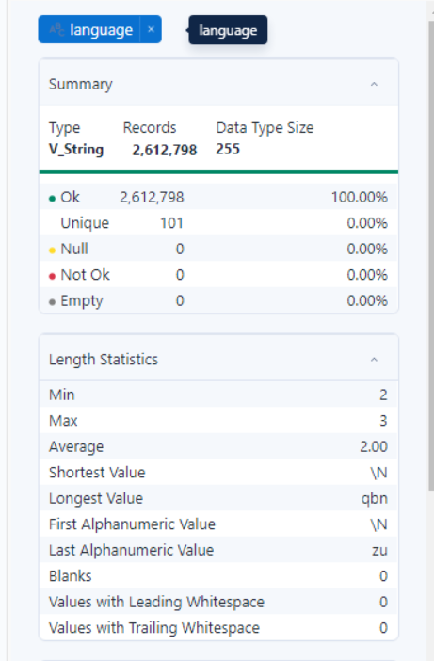

1. types – The format the movie is available in for example- Imdbdisplay, original.

Min – 2

Max – 20

No null values

Data type - String

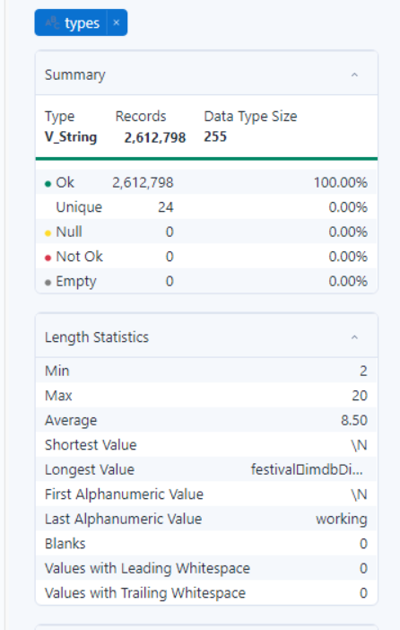

1. attributes – Information of audio versions of movie for example – dubbed , orginal subititled version

Min – 2

Max – 62

No null values

Data types - String

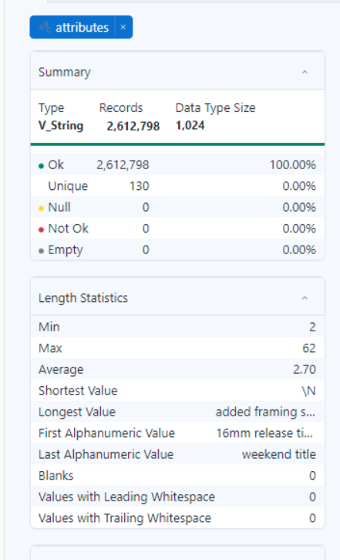

1. isOriginalTitle – Yes or a no given for 0, 1 for the movie being original or not.

Min – 1

Max – 2

Data type - Datetime

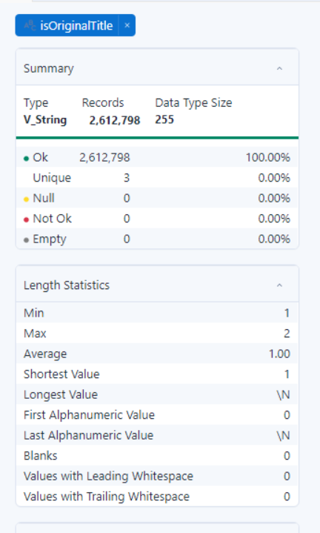

1. DI_Create_DT – system created stamp of date and time

No null values

Data type – Datetime

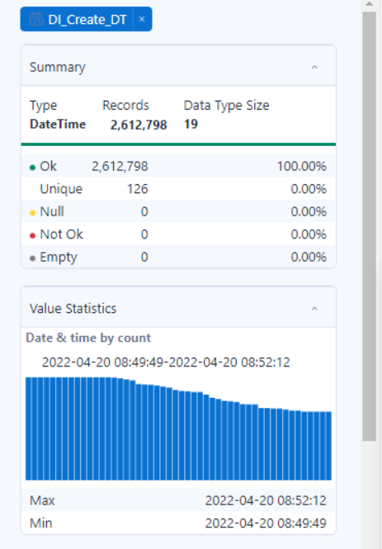

TABLE 3 – IMDB TITLE BASICS

1. Tconst – The unique code given to IMDB

Min – 9

Max – 10

No nulls

Data type - String

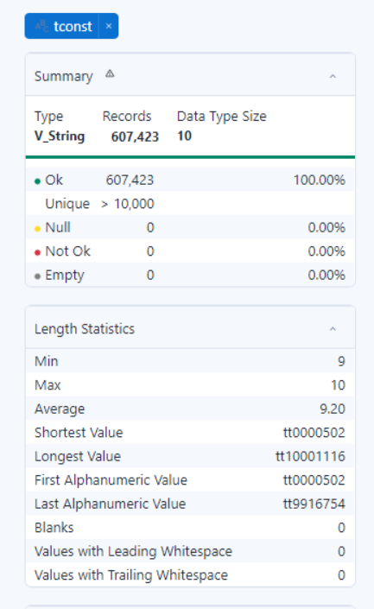

1. titleType -

Has only one value - movie

Min – 5

Max – 5

Data type - string

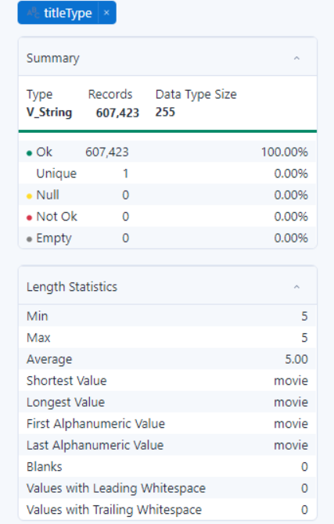

1. primaryTitle – Name given to the movie

Min – 1

Max – 242

No nulls

Data type - String

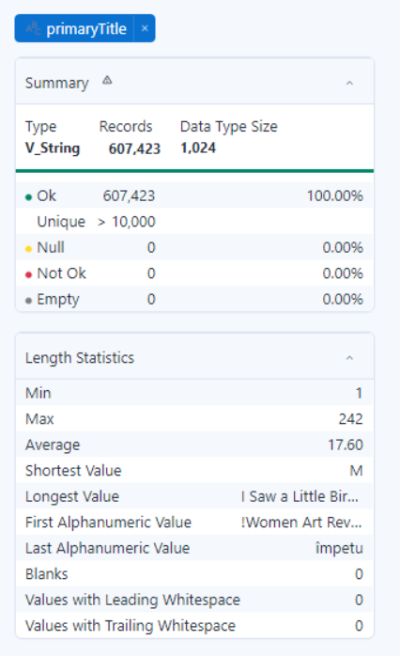

1. originalTitle – The other languages the movie was an original in.

Min – 1

Max – 2

No nulls

Data type - String

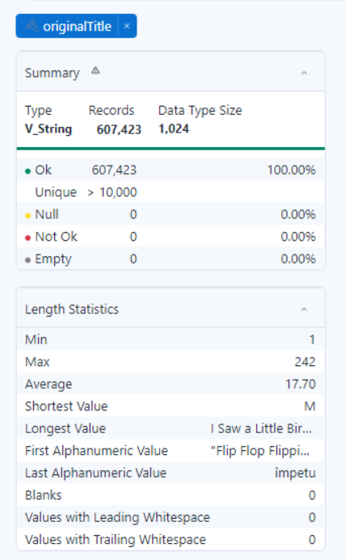

1. isAdult – True or false statement given by 0 and 1 for 18+ movie.

Min – 0

Max – 1

No nulls

Data type - INT

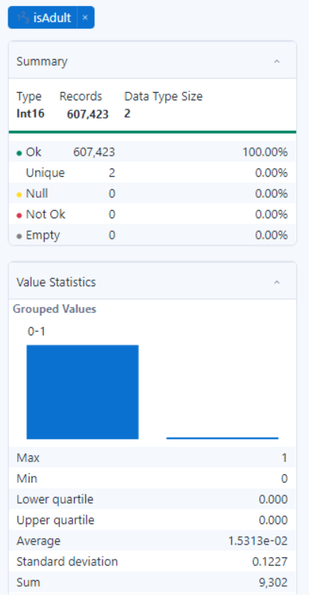

1. startYear – The year the movie that was released in.

Min – 2

Max – 4

No nulls

Data type - String

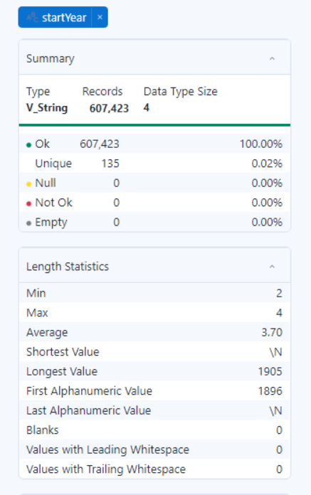

1. endYear

Has only one value - \N

Min – 2

Max – 2

Data type - String

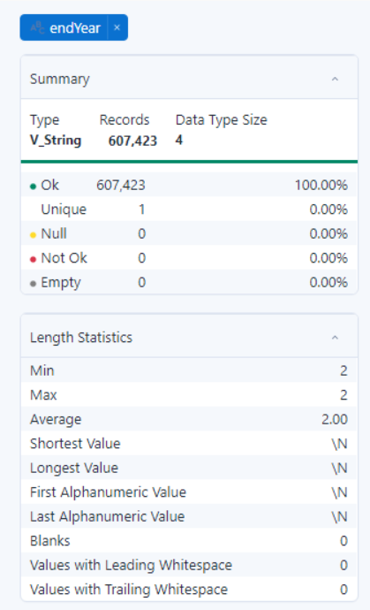

1. runtimeMinutes

Min – 1

Max – 5

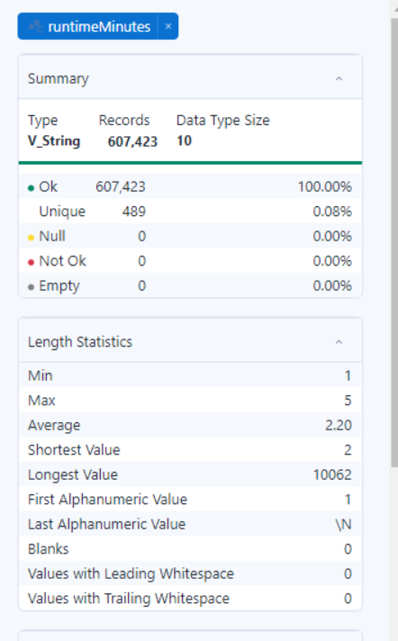

1. genres – The genre of the movie

Min – 2

Max – 32

Data type - String

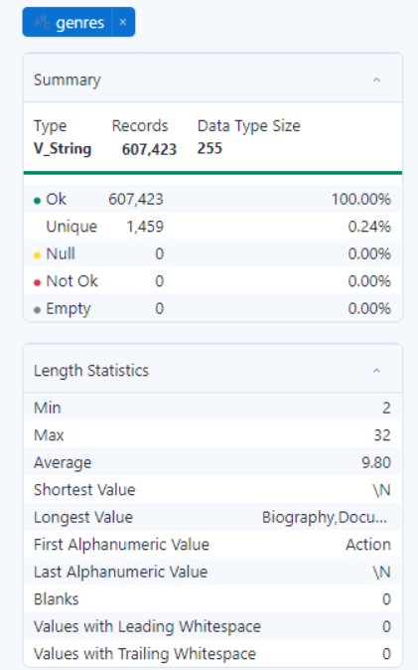

1. DI_Create_DT – system generated time

No nulls

Data type - DateTime

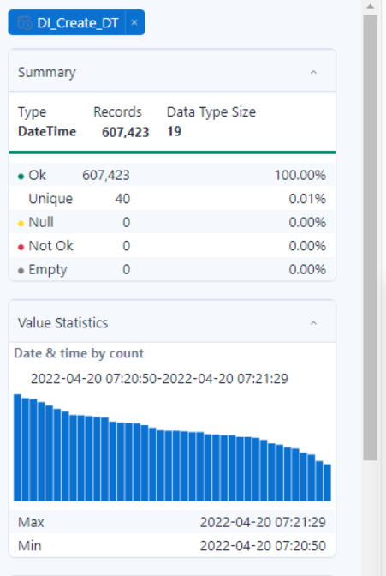

TABLE – 4 – IMDB TITLE CREW

1. Tconst

Min – 9

Max – 10

No nulls

Data type - String

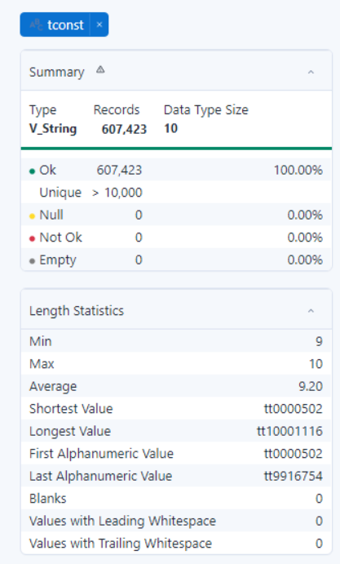

1. Directors

Min – 2

Max – 861

Data type - String

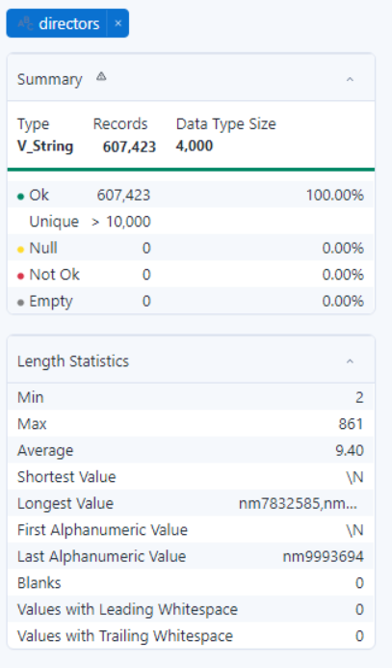

1. Writers

Min – 2

Max – 861

No nulls

Data type - String

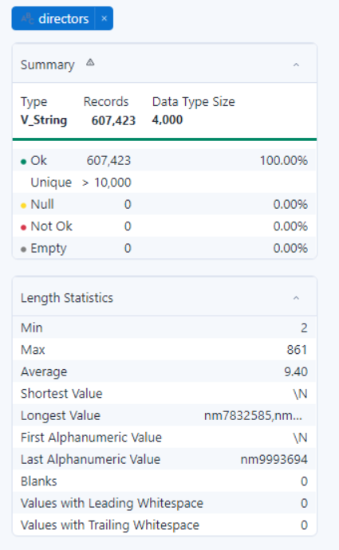

1. DI_Create_DT

Data type - String

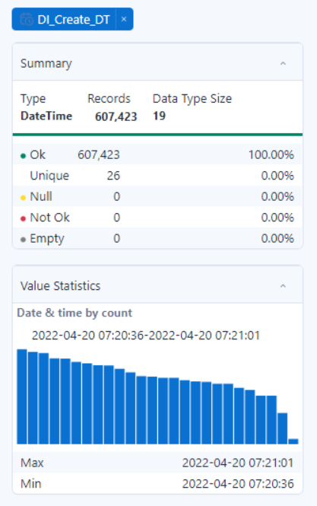

TABLE 5 – IMDB TITLE PRINCIPALS

1. Tconst

Min – 9

Max – 9

No nulls

Data type - String

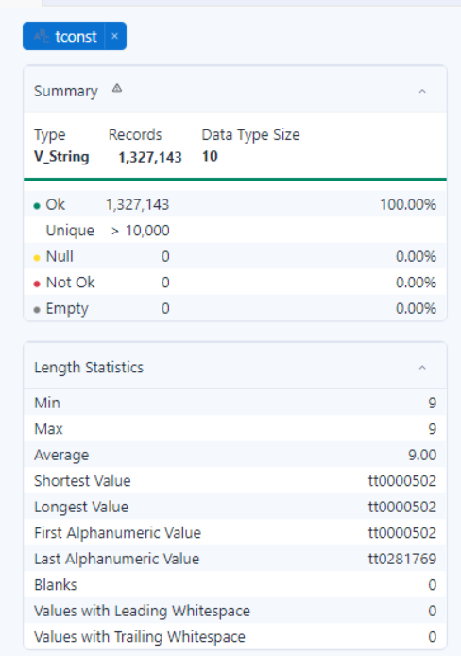

1. Ordering

Min – 1

Max – 10

No nulls

Data type - INT

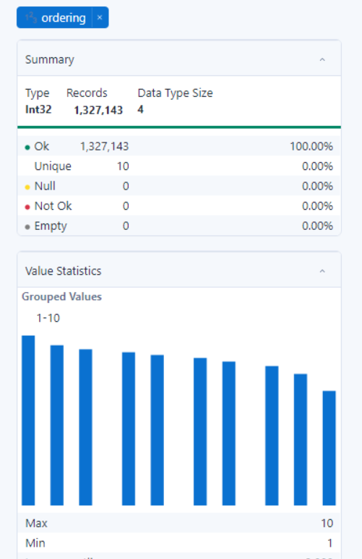

1. Nconst

Min – 9

Max – 10

No nulls

Data type - String

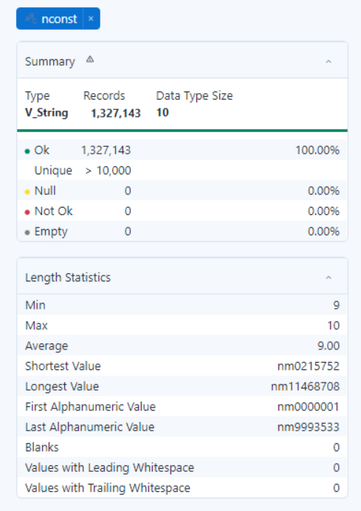

1. Category

Min – 4

Max – 19

No nulls

Data type - String

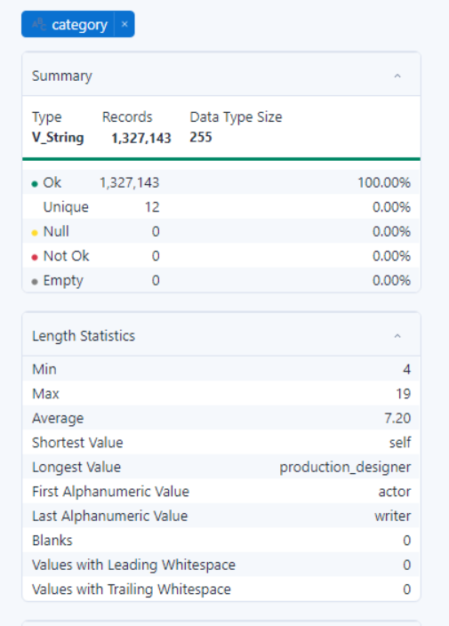

1. Job

Min – 2

Max – 157

No nulls

Data type - String

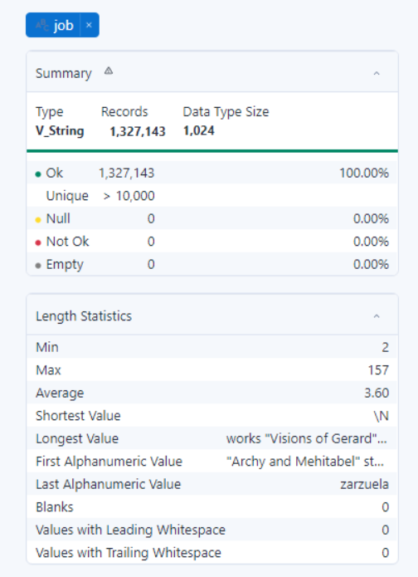

1. Characters

Min – 2

Max – 171

No nulls

Data type - String

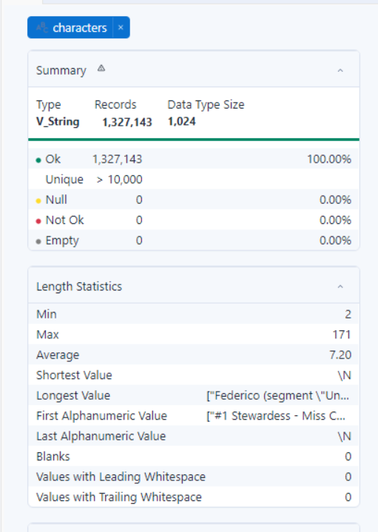

1. DI_Create_DT

No nulls

Data type - DateTime

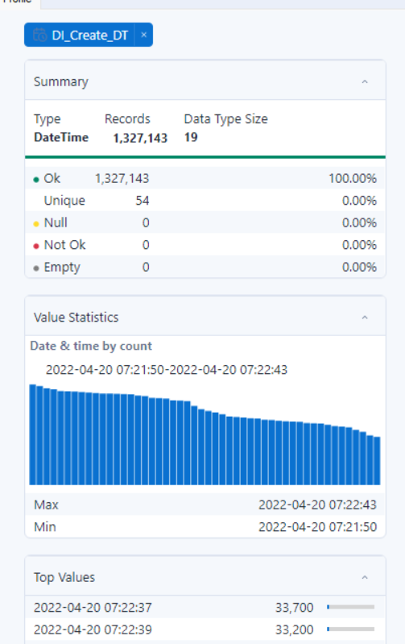

TABLE 6 – IMDB TITLE RATINGS

1. Tconst

Min – 9

Max – 10

No nulls

Data type - String

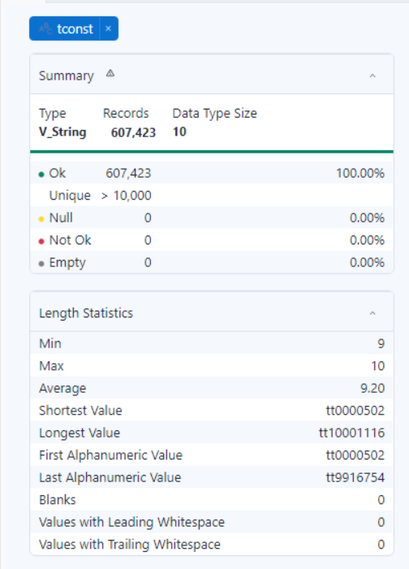

1. Directors

Min – 2

Max – 861

No nulls

Data type - String

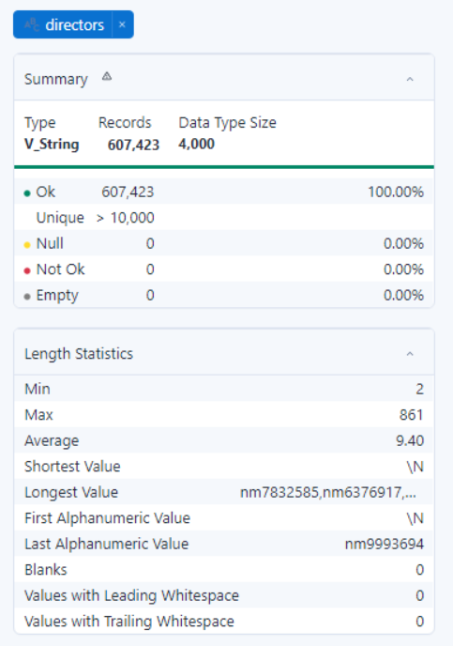

1. Writers

Min – 2

Max – 1189

No nulls

Data type - String

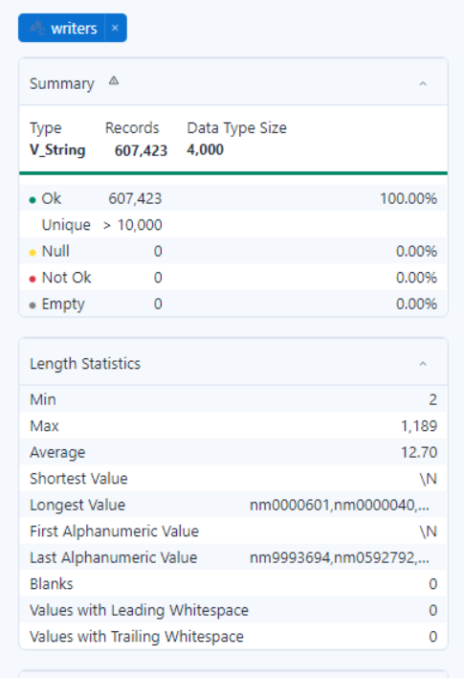

1. DI_Create_D

Data type – String

No nulls

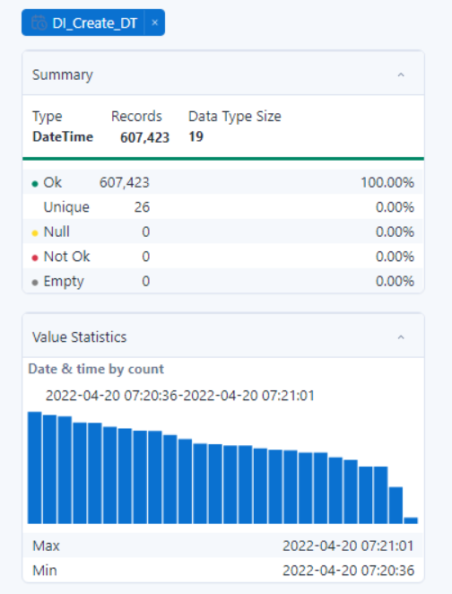

TABLE 6 –

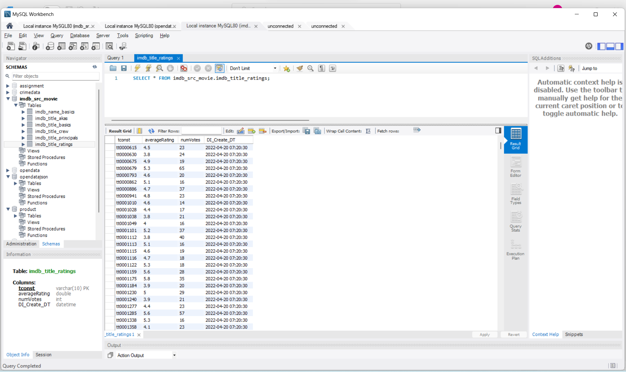

TABLE 5 –

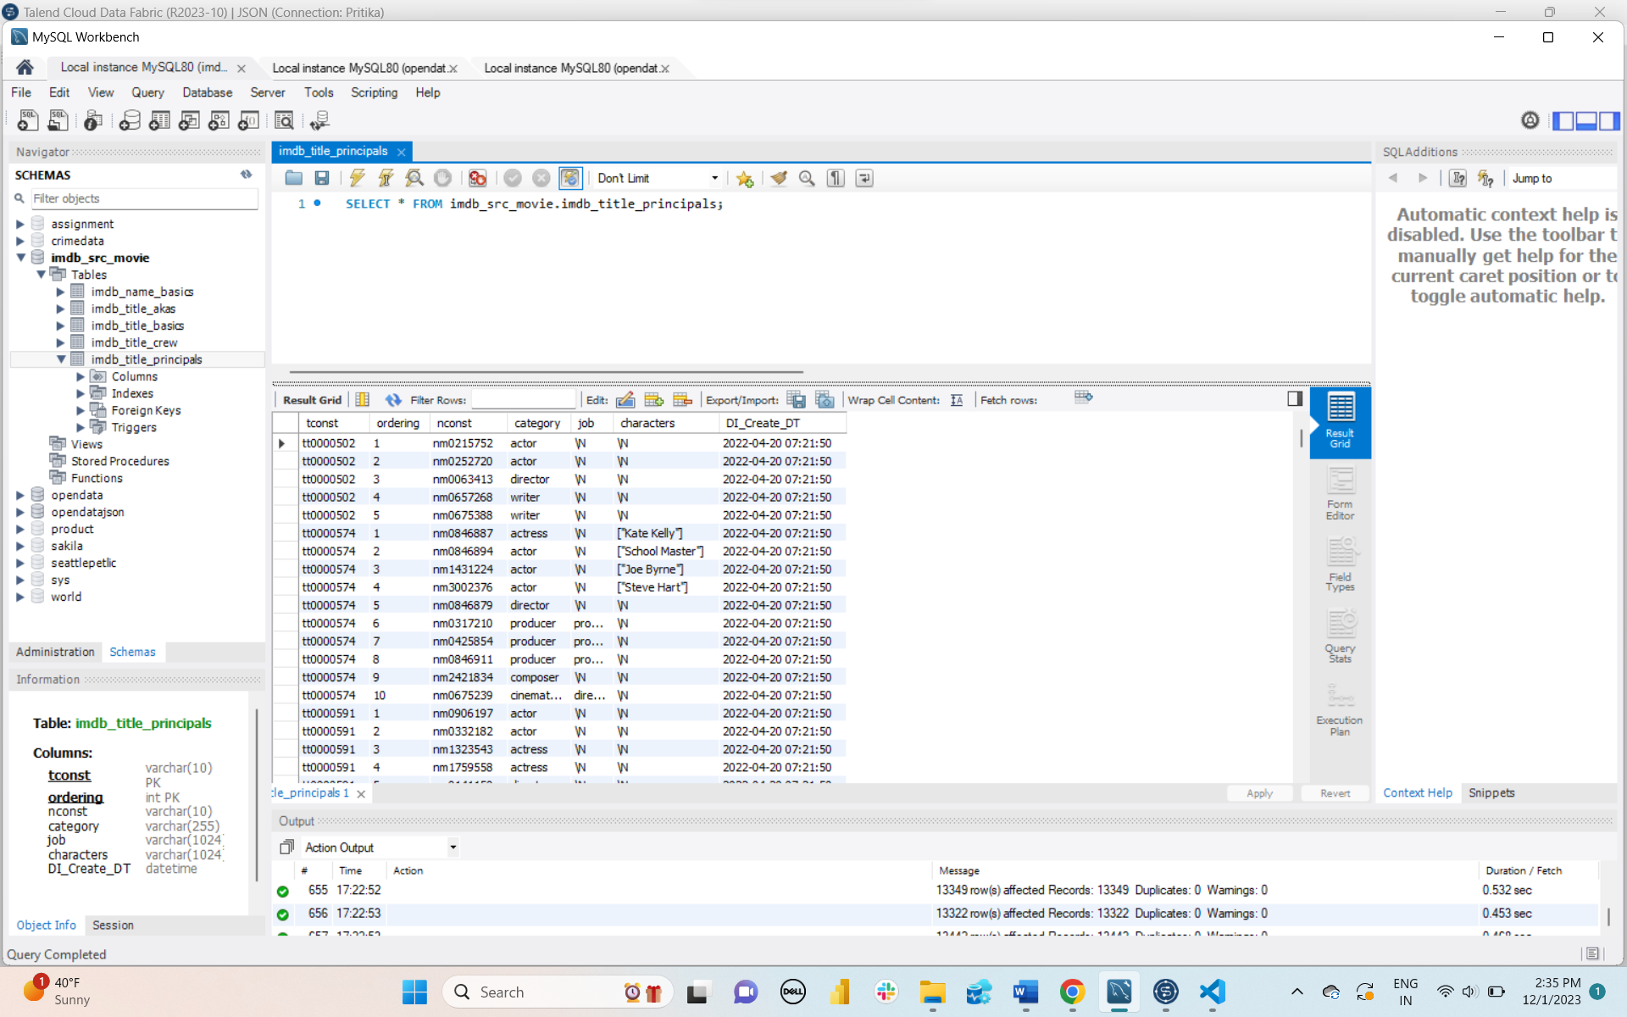

TABLE 4 –

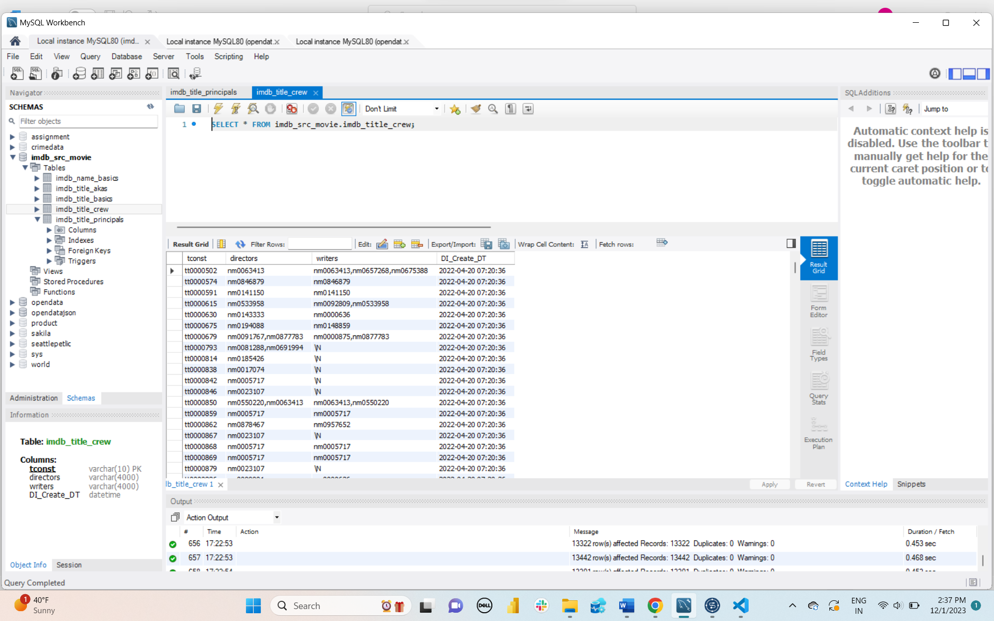

TABLE 3 –

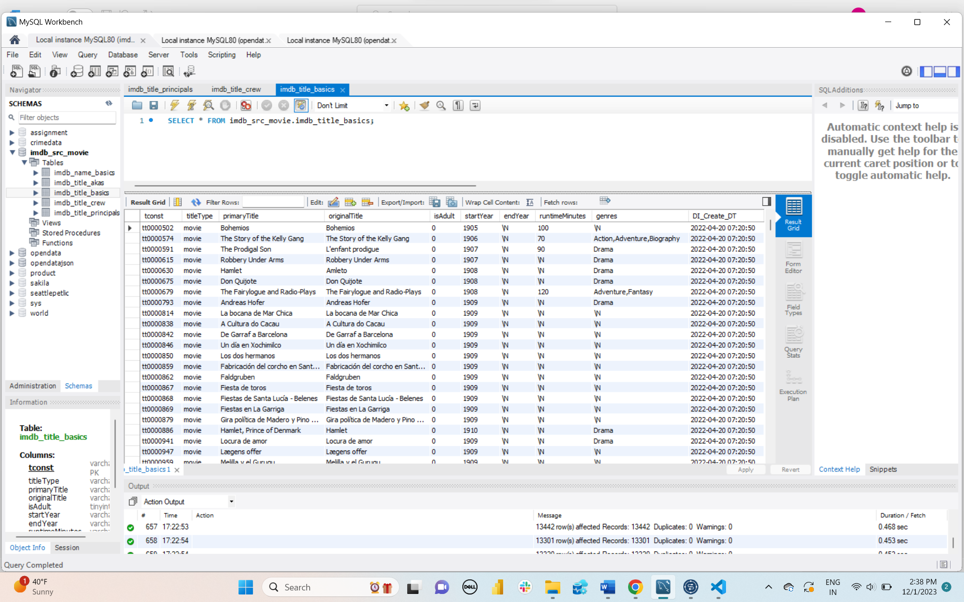

TABLE 2 –

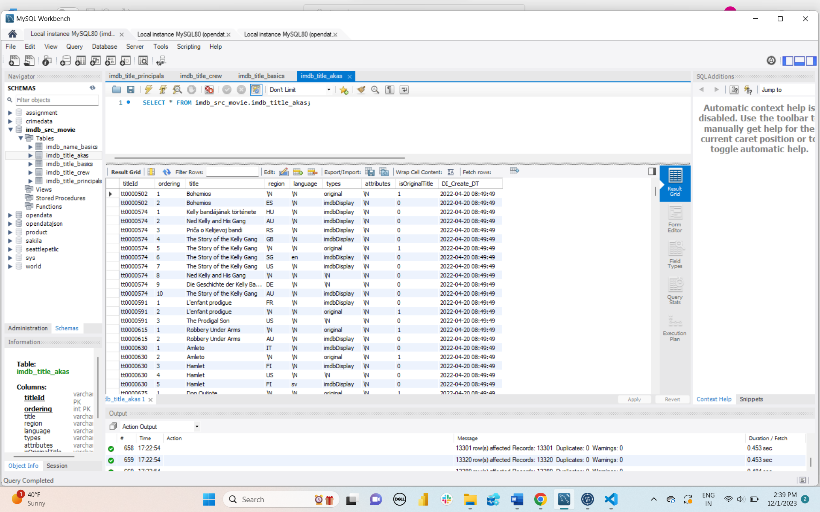

TABLE 1 –

